**Hand Gesture Controlled Bot-Overview**

This project demonstrates a **hand gesture-controlled robot** using the Arduino Nano, nRF24L01 transceiver modules, and an ADXL345 accelerometer. The bot's movements (forward, backward, left, right, stop) are controlled wirelessly by tilting your hand in different directions. The ADXL345 captures hand gestures, which are processed by an Arduino Nano, and the commands are sent to the robot via nRF24L01 wireless communication modules.

**Components Required**

* Arduino Nano
* nRF24L01
* ADXL345
* Breadboard
* Motor Driver
* Jumper wire
* Power supply (Battery)
* Chassis with wheels
* DC motors

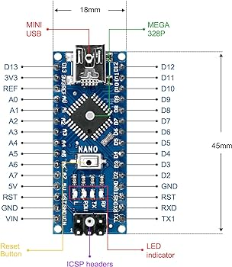**Important Components-Overview**

**1. Arduino Nano**

* **Description**: The Arduino Nano is a compact, breadboard-friendly microcontroller board based on the ATmega328P. It has 14 digital I/O pins, 8 analog inputs, a 16 MHz quartz crystal, and can be programmed using the Arduino IDE.
* **Role in Hand Gesture Controlled Bot**:
  + Acts as the **main processing unit**.
  + Reads data from the ADXL345 accelerometer (hand gestures).
  + Communicates with the nRF24L01 module to wirelessly send control signals to the robot.
  + In the receiver bot, another Arduino Nano interprets the received signals to control the motors.

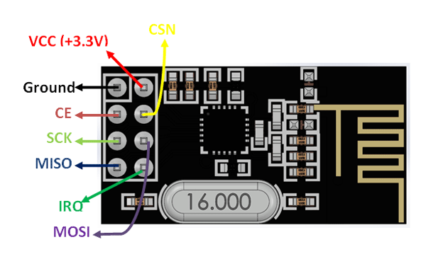**2. nRF24L01**

* + NRF24L01 is basically a wireless transceiver, which is used to send and receive data by using radio waves. It is a single chip transceiver module. It uses SPI protocol for transmitting data. Its data transmission speed is up to 2Mbps. NRF24L01 is normally used in industrial devices and projects for data transmission. It is mostly used in computer, toys, remote control, games, and other electronic devices.
* ***Key Features***
* NRF24L01 is a wireless transceiver module (works on SPI Protocol), which is used for sending and receiving data at an operating radio frequency of 2.4 to 2.5 GHz ISM(Industrial,Scientific,Mdeical) band.
* This transceiver module consists of a frequency generator,power amplifier, crystal oscillator modulator, and demodulator.
* This module is designed for long distance and fast transmission of data.
* It is designed to work through an SPI protocol.
* Air data transmission rate of NRF24L01 is around 2 Mbps.
* It is designed to work through an SPI protocol.
* Air data transmission rate of NRF24L01 is around 2 Mbps.
* This module is designed to operate at 3.3 volts.
* This module has an address range of 125 and it can communicate with six other modules. There is main eight pinouts of NRF24L01 but it also has some additional pins.

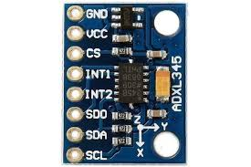**3. ADXL345**

* **Description**: The ADXL345 is a popular accelerometer sensor designed and manufactured by Analog Devices. It is a small, thin, low-power, 3-axis accelerometer that provides accurate and reliable acceleration measurements in various applications. The sensor is widely used in consumer electronics, industrial systems, robotics, and other applications where measuring acceleration is crucial.
* **Role in Hand Gesture Controlled Bot**:
  + Senses hand movements and gestures by detecting changes in acceleration along the X, Y, and Z axes.
  + The Arduino Nano reads these acceleration values and translates them into commands (e.g., forward, backward, left, right) for the robot.
  + The interpreted gesture data is sent wirelessly via the nRF24L01 to control the bot's movements.

**Working Flow Summary:**

1. **Controller Side**:
   * The ADXL345 captures hand gestures and sends the data to the Arduino Nano.
   * Arduino Nano processes this data to determine the gesture command.
   * The nRF24L01 module transmits the command wirelessly.
2. **Bot Side**:
   * Another nRF24L01 module receives the command.
   * The Arduino Nano interprets the received data and controls the motors accordingly to move the bot in the desired direction.

This setup allows you to control the robot with simple hand gestures, providing an intuitive and hands-free interface.

**Circuit Diagram**

* Transmitter/Receiver Side Arduino and nRF24L01 Connection

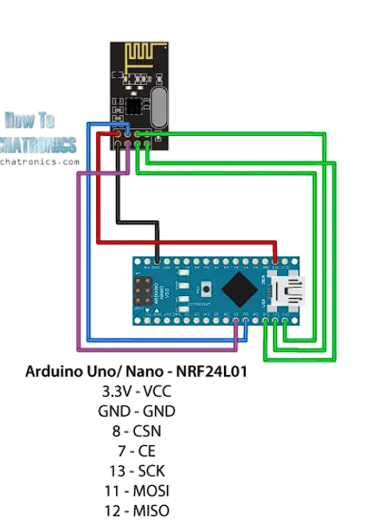

* Transmitter circuit diagram

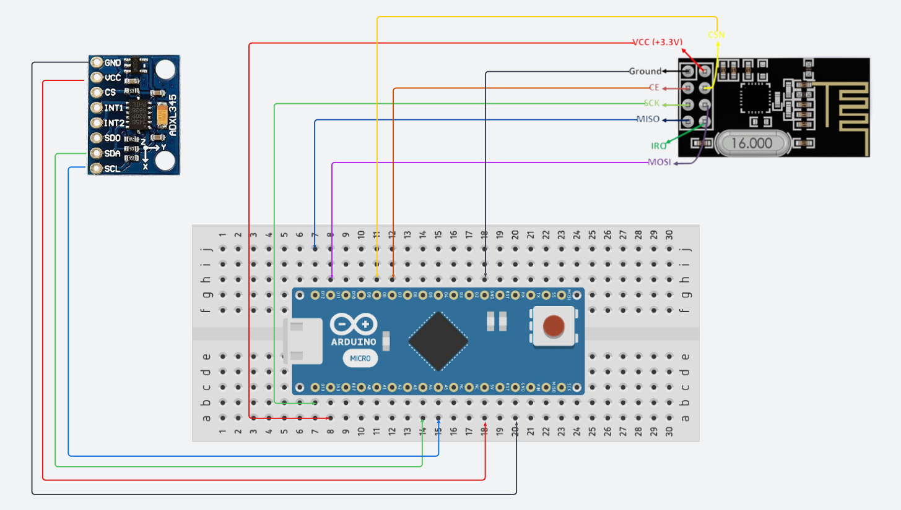

* Receiver circuit diagram

